Debugging Note Taking App

**Problems and their solutions with flow :**

* Route “/” was not allowed with GET request method

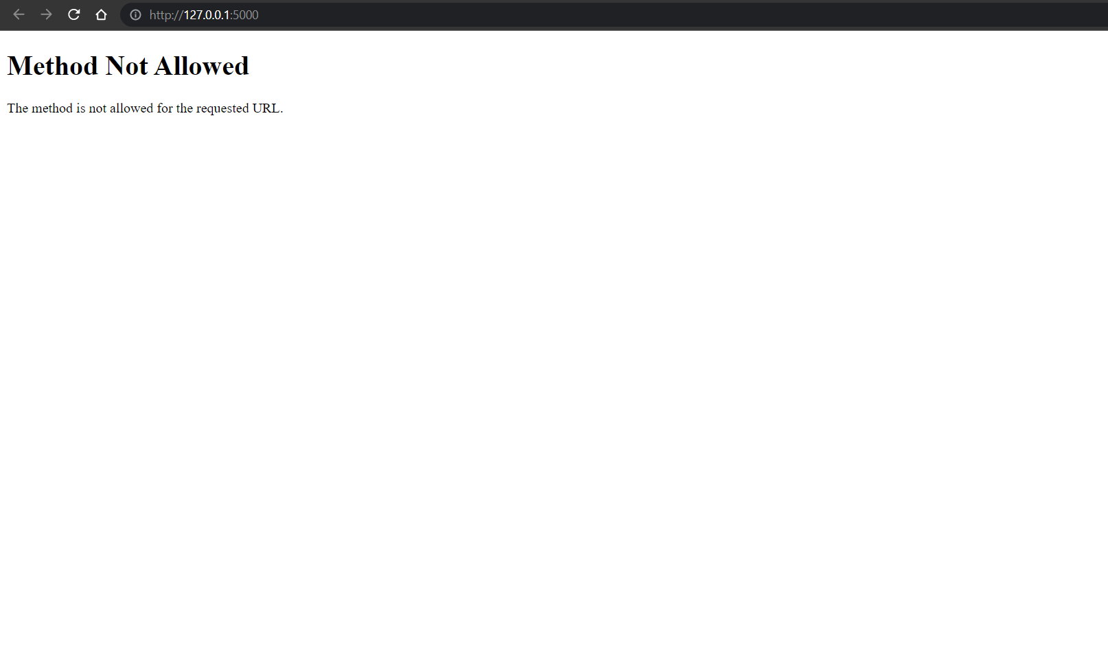

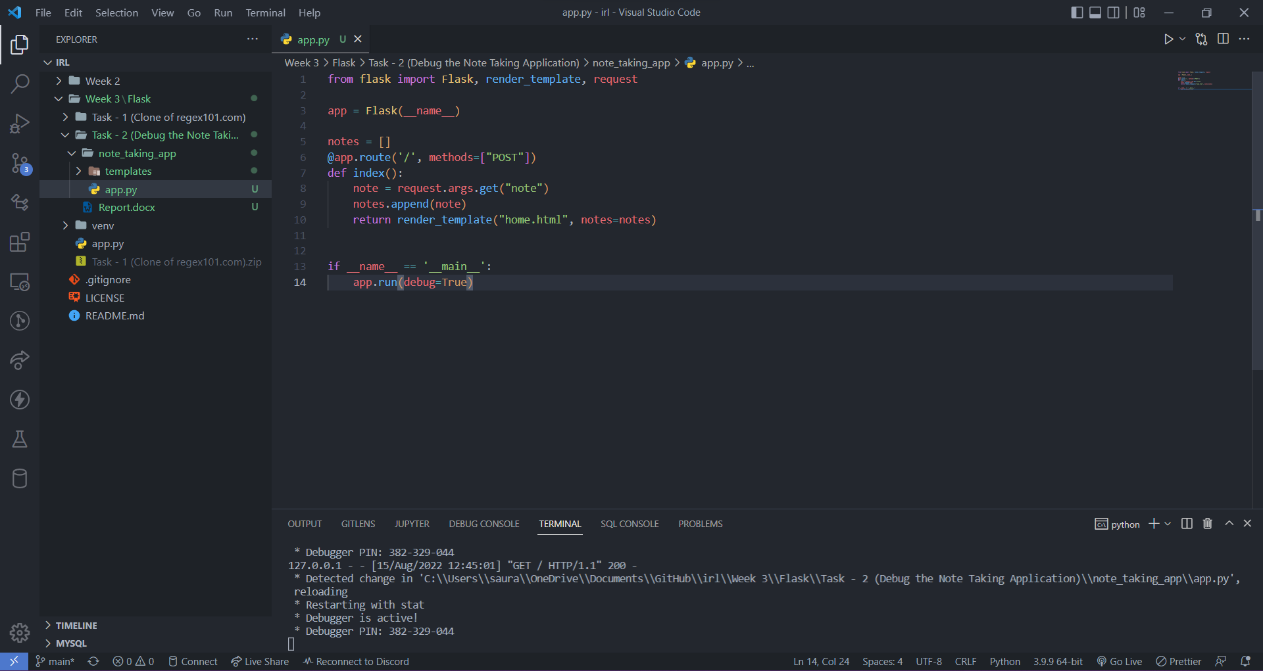

* Firstly, I changed it to just GET request method to know what is happening in app.

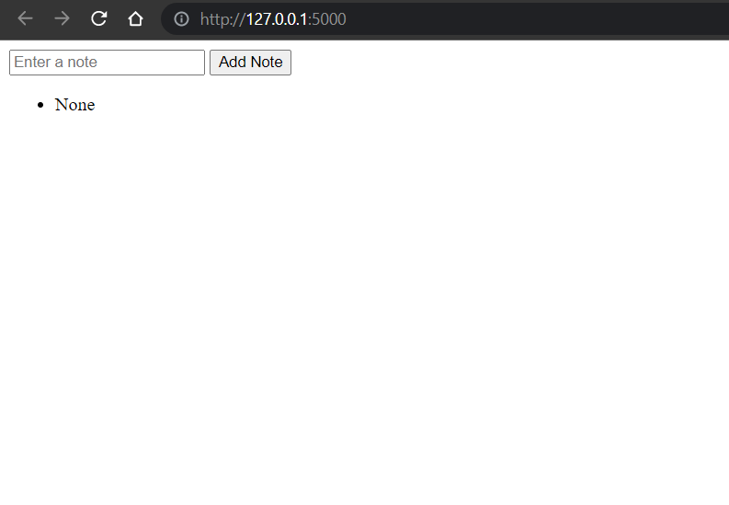

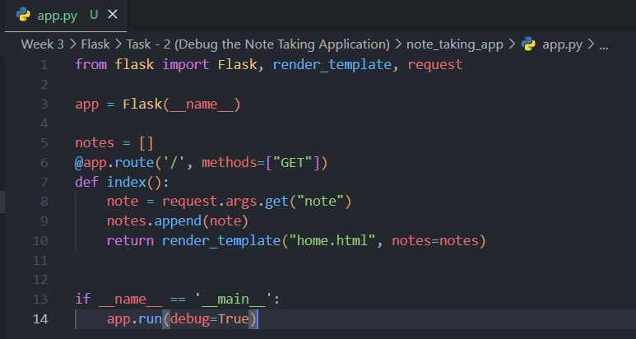

* It was displaying even empty list (i.e None) and also, note which already exist in list.



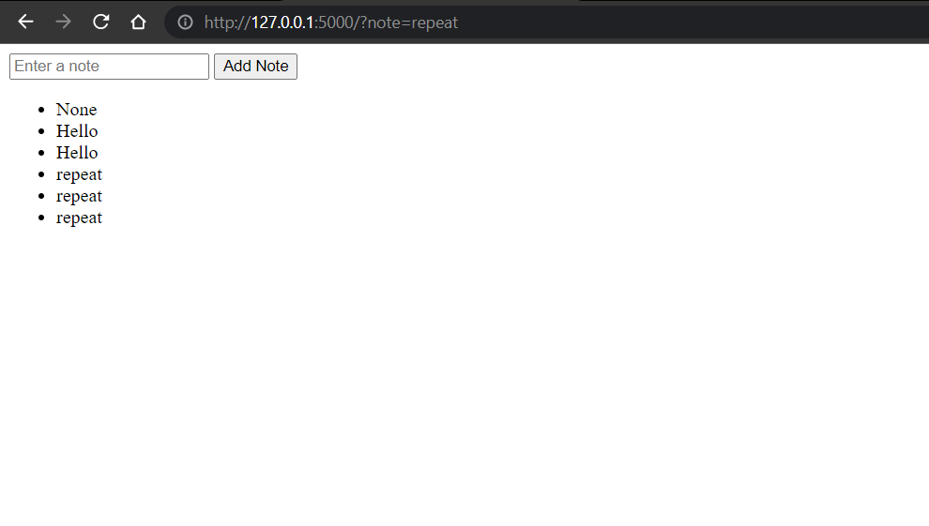

* Hence, I changed that to only display notes if list is not empty and if that note does not exist.

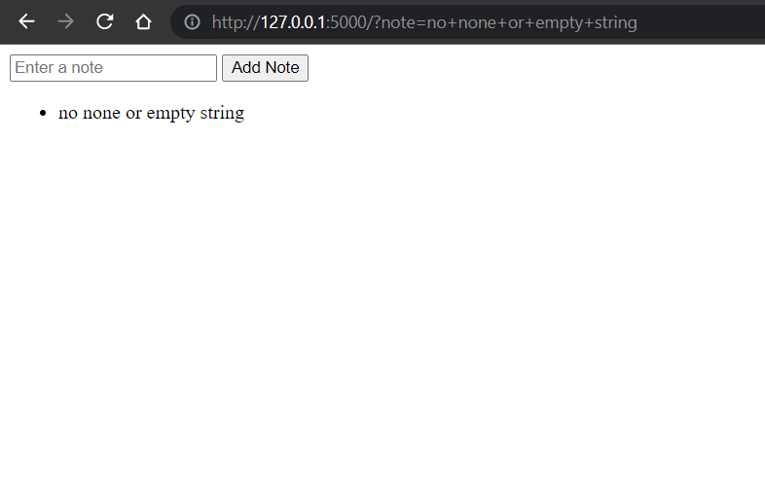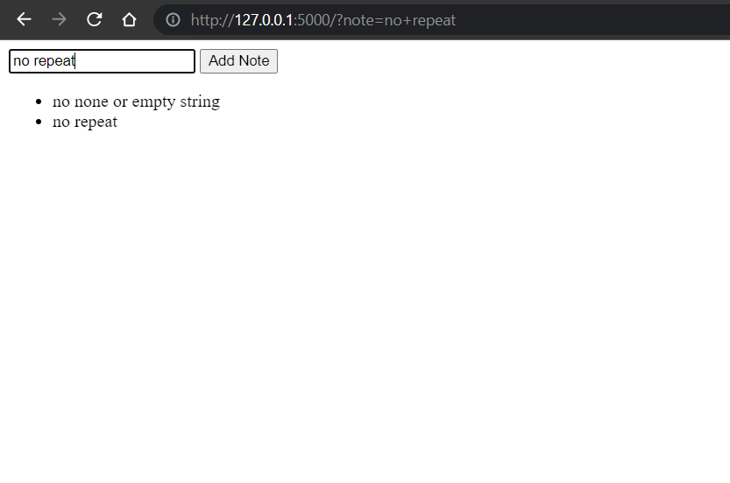

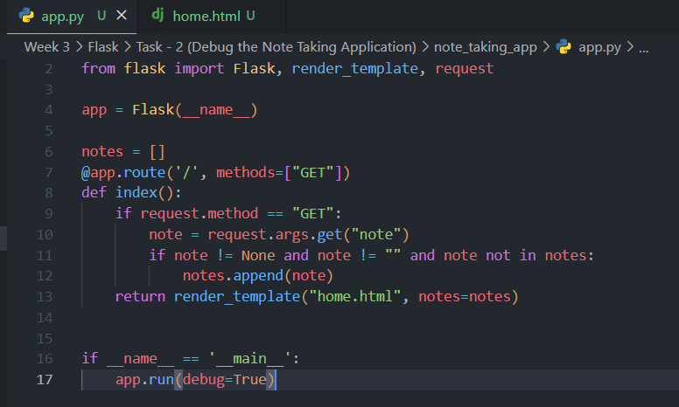

* As, the form is requesting with GET method where form data is passed in request URL we, need to change it to POST method which is more reliable and with no character cap in request.



* Now for that we need to change form method to POST.

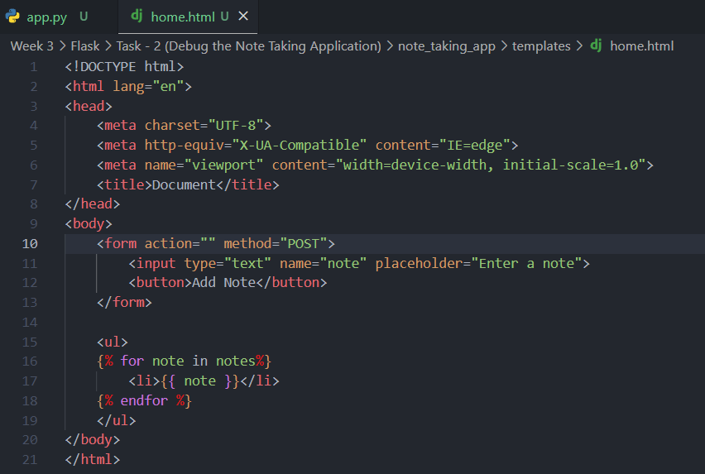

* Also, our app should be able handle both request methods.

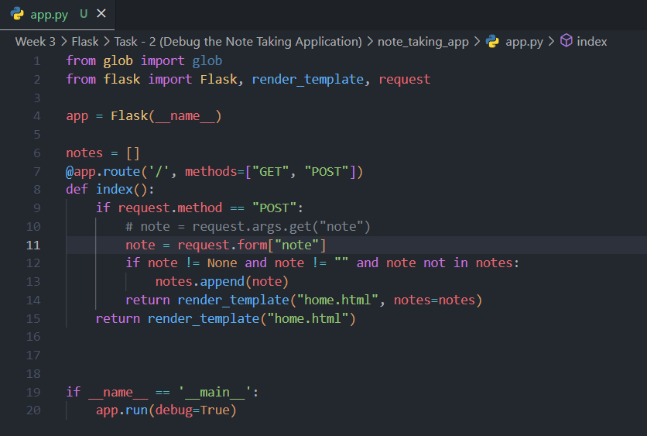

**Final Code :**

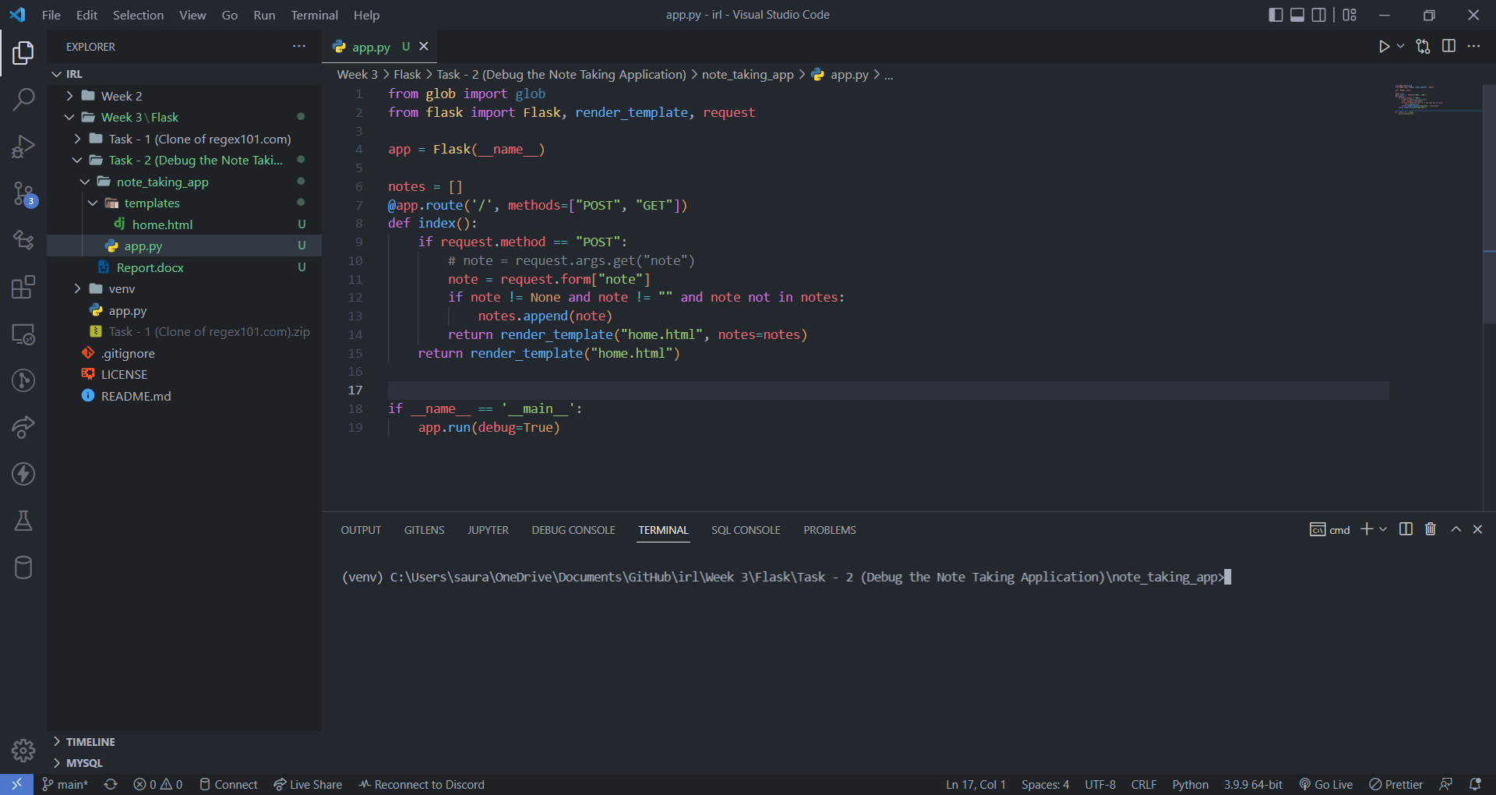

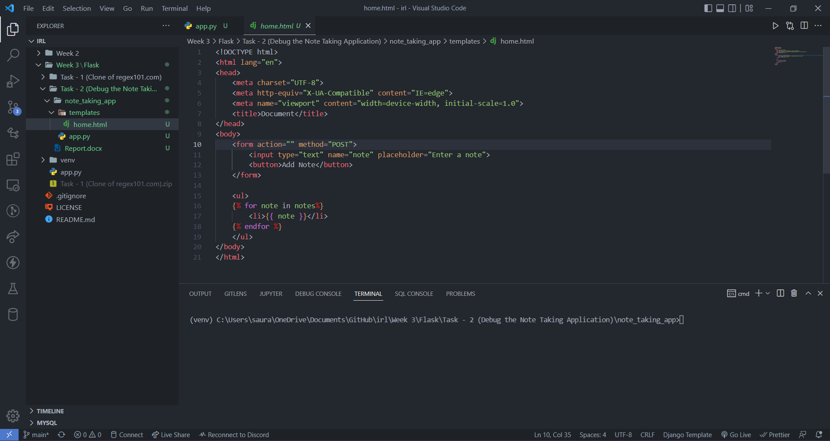

*More on project* :[GitHub Repository](https://github.com/sauravpanchal/irl/tree/main/Week%203/Flask/Task%20-%202%20(Debug%20the%20Note%20Taking%20Application))

*By :*

[*Saurav Panchal*](https://github.com/sauravpanchal)